|  |  |
| --- | --- |
| Team ID | PNT2022TMID16931 |
| Project Name | Project – News Tracker Application |
| Maximum Marks | 8 Marks |

**Deployment of app in IBM Cloud**

**UPLOAD THE IMAGE TO IBM CONTAINER REGISTRY**

1. From your account dashboard, go to **IBM CloudKubernetes** **Service.**
2. From the left navigation menu, select **PrivateRepositories**

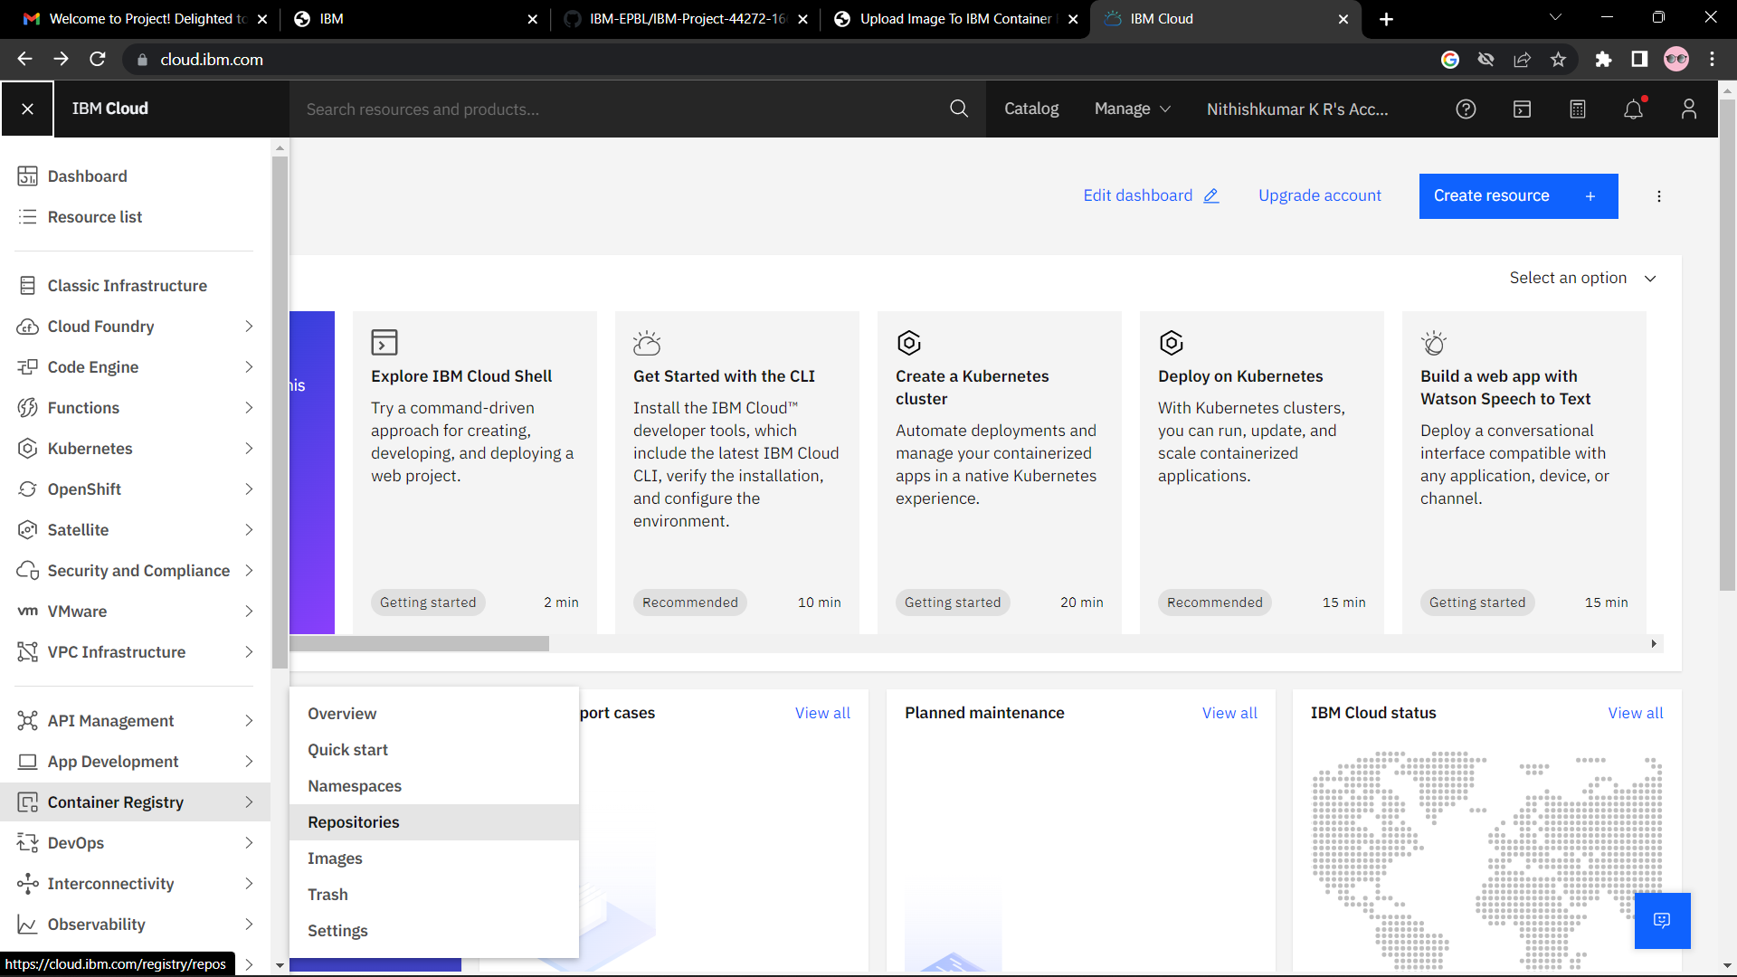

1. Install the Container Registryplug-in.
2. ibmcloud plugin install container-registry -r "IBMCloud".
3. Log in to your IBM Cloudaccount.
4. ibmcloud login – a <cloud_foundry_endpoint_for the region>.
5. Name and create your namespace. Use this namespace for the rest of the QuickStart.
6. ibmcloud cr namespace- add .<namespace>
7. Log your local Docker daemon into the IBM Cloud ContainerRegistry.
8. ibmcloud cr login.
9. Choose a repository and tag by which you can identify theimage
10. docker tag <image_name><region_url>/<namespace>/<image_name>:<tag>
11. Push the image.
12. Dockerpush<region_url>/<namespace>/<image_name>:<tag>

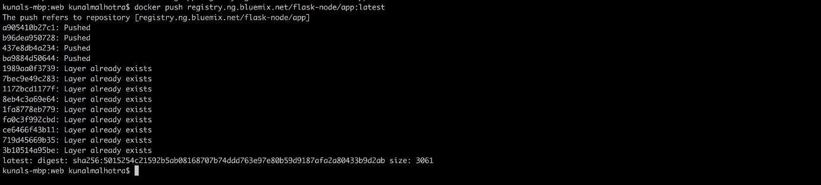

1. Verify that your image is in your privateregistry.
2. ibmcloud cr image-list.

